Digital Logic Design EE

DLD

Subject: Presentation

Project Phase: Final

Participants: 3

Submitted To Respect Sir: Syed Abbas Ali shah

Participants:

Our Group consists of 3 members.

- Muhammad Abdullah

- Umair Naveed

- Fazal Abbas

Project Title:

4way Traffic Signal Control Light

Description:

The Traffic Signal Control Light is a system that includes all the functionalities that are most commonly used in the majority of the Parking Aspects. The system have all the entities that are use within the premises of the Traffic System . Traffic Signal Control Light System working starts from the Entrance of the traffic by having the set perimeters of the Traffic Lights placed on the roads.

Procedure:

Our Traffic Signal Control Light System covers the same aspects like the majority of the Traffic Regulating systems. In the start, the system will have the lights set to zeros. The lights will be set to default in the start. According to the system, the light will change to Green after the interval of fixed time. After it, the system will wait for a few seconds and then the light among the first three lights will change to Red. The Light Category will consists of three lights columns of the same lights

- First Column-Default Light-Green Light-Red Light
- Second Column-Default Light-Green Light-Red Light
- Third Column-Default Light-Green Light-Red Light

In this project, we are going to make a 4-way traffic signal control light Using 555 Times IC. The traffic light will consist of different colours, each will specify the specific functions. Green will indicate the Regulation, Red will point to stop and similarly the rest will perform the very own respective functions. The essential or the highlighted note of our project is the usage of 555 Times IC. This project is not only limited to small project proposals or e.t.c but it can be used in real life for traffic regulations and support. Also,including the point that this traffic light project is going to be controlled manually by the user. We are hopefull that this project will be proven productive to our Traffic Regulation Authorities.

Components:

- IC-1: The IC we are using in our Traffic Light System is triple five. 555.
- IC-2: The second IC which we are using is Four Zero One Seven. IC-4017.
- Diode: The diode we used in our project is 1n4001.
- Traffic Light: We have used a single Traffic Light for our system.
- Not: We are using a not in our project as 7408.
- Resistor: We are using the entry level resistor RES in our project.
- Capacitor: C Eight Four Capacitor is going to used in our project. C84.
- LEDS: We are using pre-build LEDS for our project.
- Power Source: The Power source used in our project is a Battery as mentioned below
- BATTERY 5V: We have used a battery of 5V for our project.

All above mentioned components acts as a subsystems and work independently. However, in the proposed system they will act and coordinate as a single system to provide the desired results.

Working:

The light can be of any type mentioned above. The system will start with the first column. In the first column, the first light default light will be on first as we will provide the power. Then after a fixed interval, the default light (Yellow) will be off and the second light green will be on. The green light will stay for an interval then after the interval, the green light will be off and the third light which is red will turned on.

After the completion of the cycle of lights of the first column, the system will move towards the second column. Which also contains 3 lights. Yellow, Green and Red. The same procedure will be followed for the Second Column. At first, the Yellow light also known as default light will be on. After the fixed interval the light (Yellow) will get off and the system will move towards the second light the Green Light. The green light will be on. The system will stay on the GREEN Light for a while and then it will move on the third Light the Red Light of the second Column. The system will take a lap at the Red light of almost 3-4 seconds.

The Third Lap of the system will start in the Last phase. Similarly like the previous two phases. The system will first start by the Default light. The system will stay there for 3-4 seconds. After it, the system will move towards the second light and the second light Green Light will be on. Then the system will move on the third light and the Red light will be on.
After the supply of the power in the Traffic Light System, we will have round about 4-5 Traffic Functionalities.

Functions:

These functionalities include:
- Regulation of the Daily Traffic
- Proper Restraining by the use of Red Light
- Allowing the Passing by means of Green Light
- And the Yellow Indicator as a signal of Stop and Start.

Aside of it, we will ensure the regulation should be proper and the hardware should be balanced to carry out the respective Task. In addition to these functions, our system will also have a reset functionality. With the reset function, the whole record of the lights, will be again reset to zero. At last, Our Lights will start from the beginning after the completion of the whole cycle.

Objective:

The main objective of our Project is to provide you with the intermediate level Traffic Management System in order to run your Traffic by having a proper check and balance of it. Also, our system will perfectly handle the different types of Traffics by switching the lights separately and stoping and regulating all the vehicles after the fixed intervals. So by this project. It will become a lot easier to manage your Daily Traffics with proper check and balance and departure functionality.

Prototypes:
Phase-I
Phase-II
Phase-III

Prototype-I:
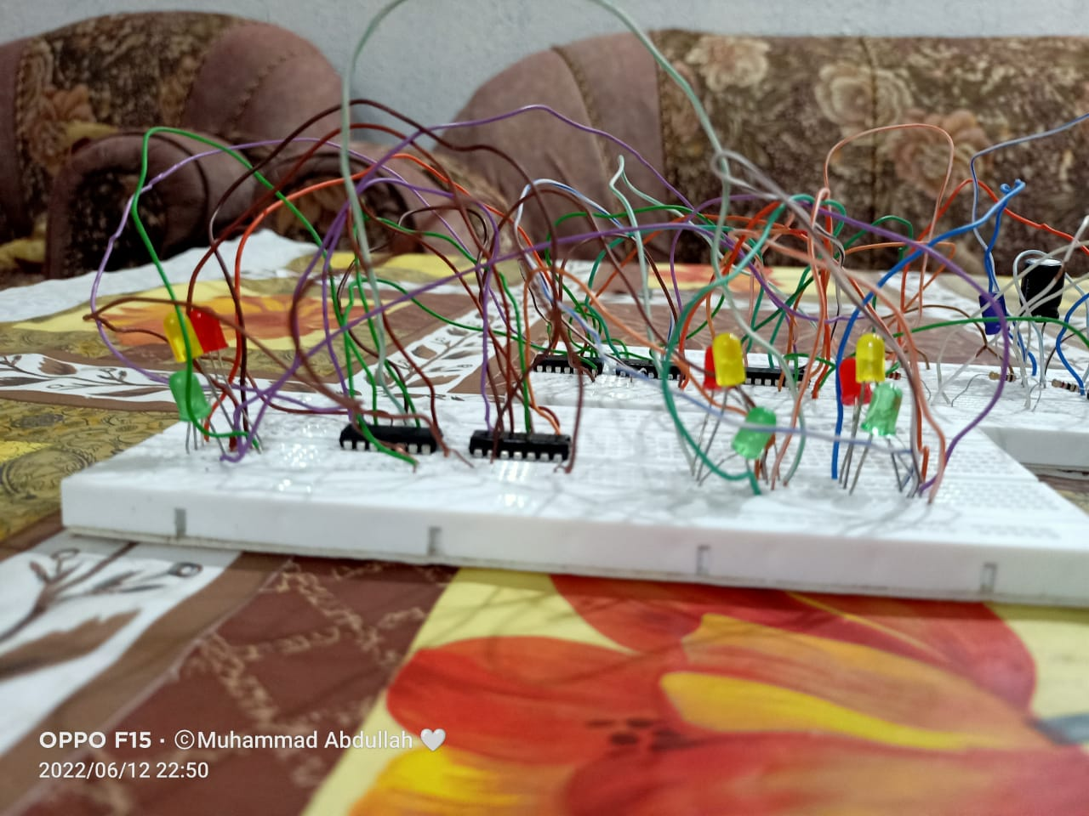

Prototype-II:

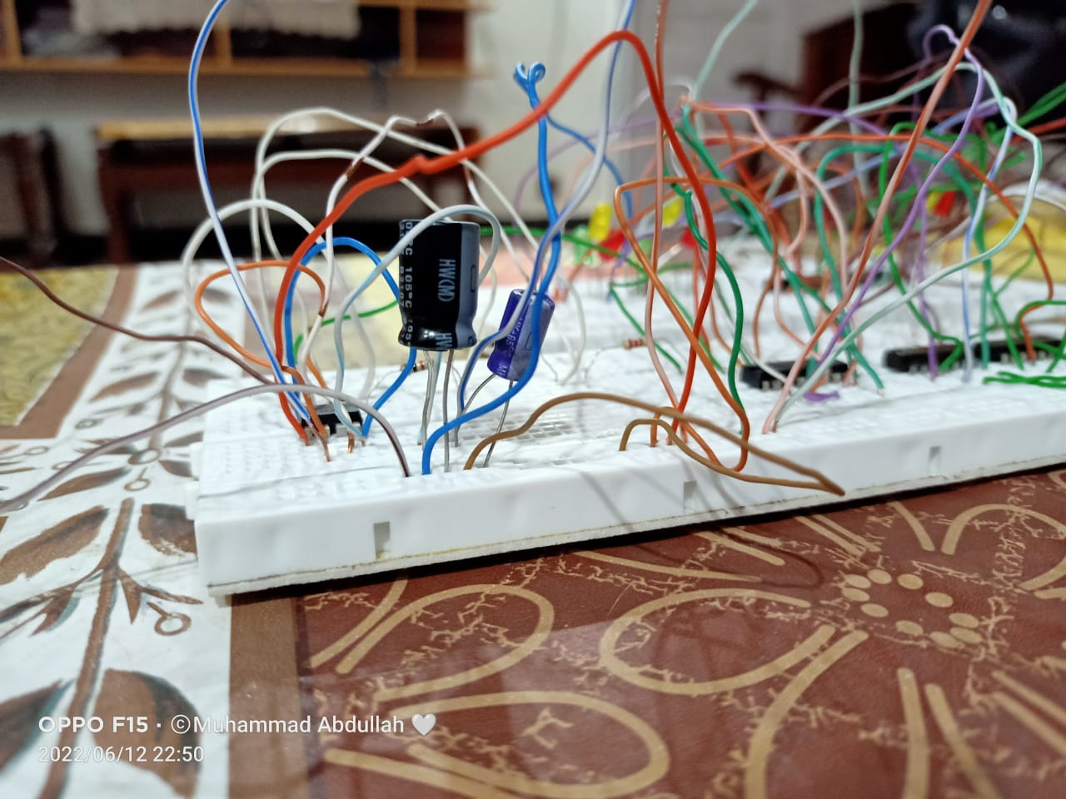

Prototype-III:

